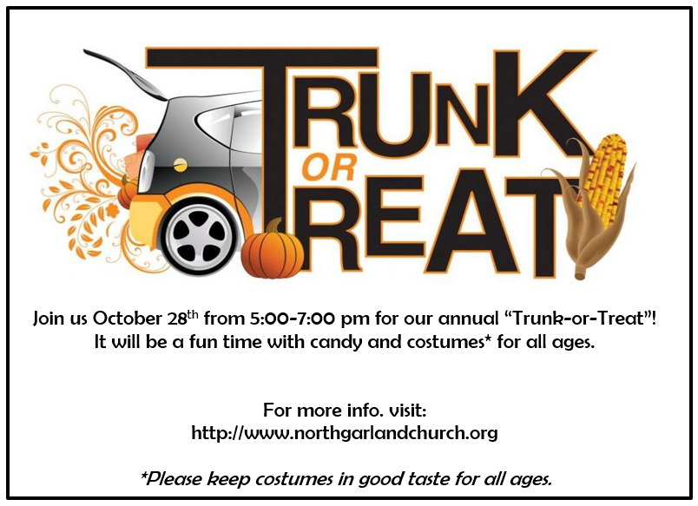

Join us October 28th from 5:00-7:00 pm for our annual “Trunk-or-Treat”! It will be a fun time with candy and costumes* for all ages.

For more info. visit:
http://www.northgarlandchurch.org

*Please keep costumes in good taste for all ages.

